STANDARD OPERATIONAL PROCEDURE FOR RESPONDING TO INAPPROPRIATE CONTENT POSTED ON TRICKLE IN NHS LOTHIAN

1 | INTRODUCTION
2 | SCOPE / DEFINITIONS
3 | ANONYMOUS POSTING
4 | INAPPROPRIATE CONTENT
5 | WHISTLEBLOWING CONTENT
6 | REVIEW OF POLICY

1. INTRODUCTION

  - Trickle is an online forum for Doctors in Training to highlight areas of practice that are done well, identify areas for improvement within our workplace, and come up with ideas to improve the ‘working world’ of junior doctors.

  - Trickle is a social media platform, therefore, this Standard Operational Policy (SOP) should be read in conjunction with NHS Lothian’s Social Media Policy and NHS Lothian’s eHealth Security Policy.

  - NHS Lothian’s Social Media Policy is clear in identifying content that would be inappropriate to post on social media. This is equally attributable to users of Trickle. The policy lists several examples (this list is not exhaustive), including conduct that would:

- breach patient confidentiality, trust or ethics by sharing of confidential information;
- constitute bullying or harassment of an individual or group;
- constitute defamation of an individual’s character by posting inappropriate comments about a colleague or patients ;
- discredit the services provided by NHS Lothian or discredit NHS Lothian as an employer;
- discredit a particular profession.

  - Whilst Trickle is envisioned as an area where doctors can talk about improving aspects of their working lives, it should not be used for formal whistleblowing concerns (e.g. fraudulent practice, criminality). Examples of such concerns are set out under NHS Lothian’s Whistleblowing Pages on the staff intranet, and staff should be encouraged to raise issues locally in the first instance as set out in NHS Lothian’s whistleblowing policy.

  - NHS Lothian’s Values are also a key guiding principle in the use of the Trickle platform.

2. DEFINITIONS / SCOPE

  - The web-based software/platform is called ‘Trickle’

  - Doctors in Training registered on Trickle will be known as ‘Community Members or User’

  - A new discussion/idea is called a ‘Post’
    - All discussions related to that post are ‘comments’

  - Oversight, review and administration of posts/comments on Trickle will primarily be done by the ‘Trickle Champions’
    - Trickle Champions will initially be the NHS Lothian Chief Registrars and the Associate Director of Medical Education (ADME). This will be reviewed and may be expanded.
    - Trickle Champions will primarily look after posting relevant to their location or ‘site’ (WGH, RIE, RHSC, RIE, SJH etc).

  - This scope of this policy is intended to guide Community Members and Trickle Champions in the event of an inappropriate post being made. This includes appropriate signposting and escalation. Trickle is envisioned as a community forum, and with that, we hope NHS Lothian’s Values of ‘Teamwork’ and ‘Openness, Honesty and Responsibility’ will mean that potentially inappropriate content can be acted on by users within the Trickle community. This may need to be updated following the roll-out of Trickle amongst doctors in training in NHS Lothian.

3. ANONYMOUS POSTING

  - For the initial launch of trickle we have decided to turn anonymous posting off this will be reviewed after 6-8 weeks of trickle use
    - The reasoning for this is that the platform does not currently have the safeguards we require there are concerns that people will hide behind anonymity to post inappropriately
    - This is carefully balanced against wanting to give all trainees in Lothian a voice and we realised that by NOT allowing anonymous posting we will lose ‘traffic’ and lose some voices as people are usually less comfortable to put their name on an issue.
    - We are working with the Trickle platform developers to introduce slight changes in the way anonymous posts can be reviewed and may be in a position to introduce anonymous posting at a later date.

4. INAPPROPRIATE CONTENT

  - A post or comment may be flagged as being inappropriate by a community member or identified by a Trickle Champion.

  - If a post or comment is flagged then it will become locked (i.e. the post will not be visible) with an accompanying message stating that the post/comment has been flagged as potentially inappropriate, and is pending review.

  - Any Trickle flagged as inappropriate will be brought to the attention of all Trickle Champions. It should be the primary responsibility for the champions for that hospital site to review the post/comment. It is envisioned that all flagged posts will be responded to within 48 hours of being highlighted as potentially inappropriate.

  - The site Champions will then decide on the next course of action for the locked post/comment.

  - The user who posted the content should then be contacted via email. The reason the post/comment has been locked will be explained and the relevant policy/guidance it is in breach of.
    - The course of action taken will depend on the nature of the post – e.g. removing one’s ability to post anonymously may be sufficient, whilst in some instances it may be appropriate to notify their educational supervisor.

  - In some instances, deciding what content is ‘inappropriate’ may be more subjective. It may be that parts/elements of the comment/post are important things to discuss.

  - NHS Lothian Values will provide the guiding principles for review and further discussion between Trickle champions as required.
    - If it is deemed not to be in keeping with NHS Lothian values the post/comment will remain locked and the community member contacted via email to support, explain and discuss further.
    - If the post/comment is in keeping with NHS Lothian values then the post will be released. It may be that the Trickle champion needs to add a comment to the thread to encourage/guide towards a constructive conversation.

  - If anonymous posts are flagged as inappropriate then the same process of review will be followed by the Trickle champions for that site.
    - It may be that the post contains important staff/patient safety issues that should be addressed quickly.
    - The Trickle platform is not able to ‘unmask’ the identity of the community member that posted anonymously but it can prevent further anonymous posting by that community member

5. WHISTLEBLOWING CONTENT

  - A community member may use Trickle to highlight whistleblowing concerns. This is beyond the scope of Trickle: its main use is to highlight parts of the working world that could be improved as opposed to dangerous or illegal practices. In these instances, it is suggested that the Trickle Champion contacts the user, and alerts them to NHS Lothian’s Whistleblowing policy, guidance on how to raise a concern and/or signpost them to Speak Up advocates.

6. REVIEW OF POLICY

  - This policy will be reviewed in 6 months time by the Chief Registrars in the Medical Education Directorate, NHS Lothian.

Version History (This can be removed once the draft SOP is verified)

Keep track of changes here.

Document Version | Date | Author | Remarks
1.0 | 20/12/2019 | Chris O'Shea | Initial Template Created
2.0 | 20/01/2019 | Dan Hufton | Anonymous posting section added  Minor reformatting changes  Definitions added, rewording of some sections  Inappropriate Trickle SOP Process Mapp added
3.0 | 23/03/2020 | Dan Hufton | Anonymous posting section changed to reflect decision NOT to launch trickle with anonymous posting turned on
4.0
5.0

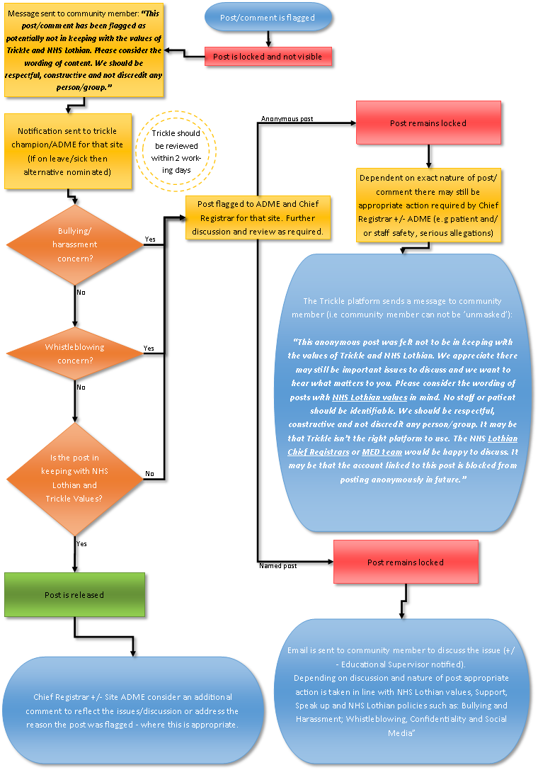
Inappropriate Trickle SOP process map

